

NAME : BISMA FATIMA
CLASS : CS A
ROLL NO: F24605036
COURSE : COMPUTER NETWORK
COURSE CODE : CS-271
LECTURER : SIR NAVEED YOUSAF

LAB 02

In Lab Task 01
Step-By-Step Procedure
- Obtain samples of UTP (Cat5e or Cat6), coaxial, and fiber optic cables.
ANS:
- UTP (Cat5e/Cat6): Commonly used for Ethernet; available at electronics or networking supply stores.
- Coaxial: Used for cable TV and older networking; look for RG6 or RG59 types.
- Fiber Optic: Used for high-speed data; single-mode or multi-mode variants with ST, SC, or LC connectors.

- Visually inspect and handle each cable type. Note the differences in flexibility, thickness, and connector types.
ANS:
Cable Type | Flexibility | Thickness | Connector Type
Cat5e/Cat6 UTP | Flexible (Cat5e more so) | Medium (Cat6 thicker due to separator) | RJ45
Coaxial | Semi-rigid | Thick (due to shielding) | F-type, BNC, RCA
Fiber Optic | Least flexible | Thin core, thick jacket | ST, SC, LC, SMA

- Examine the internal structure of a UTP cable segment. Identify the twisted pairs of wires and their color coding.
ANS:
- Strip ~2 inches of the outer jacket.
- Inside, you'll find 4 twisted pairs:
  - Orange + White/Orange
  - Green + White/Green
  - Blue + White/Blue
  - Brown + White/Brown
- Twisting reduces electromagnetic interference (EMI).
- Color coding follows TIA/EIA-568A or 568B standards.

- Obtain pre-made straight-through and crossover Ethernet cables.
ANS:
- Straight-through: Same wiring on both ends; used to connect different devices (e.g., PC to switch).
- Crossover: Swaps transmit and receive pairs; used for similar devices (e.g., PC to PC).

- Examine the RJ45 connectors at both ends of the straight-through cable. Compare it to the T568A and T568B diagrams. Determine which standard was used.
ANS:
Hold both connectors with the clip facing down and pins facing you. Compare wire order to these standards:
Pin | T568A Color | T568B Color
1 | White/Green | White/Orange
2 | Green | Orange
3 | White/Orange | White/Green
4 | Blue | Blue
5 | White/Blue | White/Blue
6 | Orange | Green
7 | White/Brown | White/Brown
8 | Brown | Brown
- If both ends match T568B, it's a straight-through cable using that standard.

- Using a cable tester tool, insert both ends of the straight-through cable. Verify that the pinout corresponds to a 1-to-1 connection.
ANS:
- Plug each end into the tester.
- A proper 1-to-1 pinout will show:
- LED 1 lights up for pin 1, LED 2 for pin 2, and so on through pin 8.
- If the sequence is jumbled or reversed, it may be a crossover or faulty cable
Introduction of Cisco Packet Tracer and Topologies
Warm up Task
Open your packet tracer simulator and Sign in using cisco id.
Step 1 . Click on the End User Devices icon.
Record any 5 devices Names and screen shot.
a. PC
b. laptop
c. server
d. network computer
e. Printer
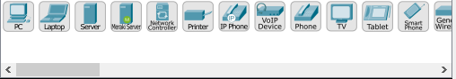

Step 2. Click on the Network Devices icon.
Record any 3 devices Name, screen shot and 3 to 4 lines of description of your understanding about device.
a. 4331
b. 4321
c. 1941

Step 3. Click on the Device Connection icon.
Identify wires, record each wire purpose in 2 to 3 lines and Fill the blanks.
a. crossover (PC to PC)
b. straight through (PC to Switch)
c. Cross over cable (Switch to Switch)
d. Cross over cable (Switch to Router)
e. Straight Through (Router to Router)
Lab Task 2
By using Drag and drop draw topology diagram as Shown below and attach screenshot of each step.
1. Pc
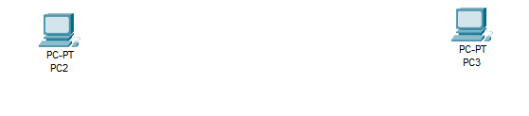
2. Switch (2950-24)
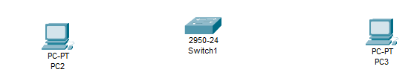
3. Assign IP to Pc-1 interface (IP 192.168.2.2 --- Subnet Mask 255.255.255.0).
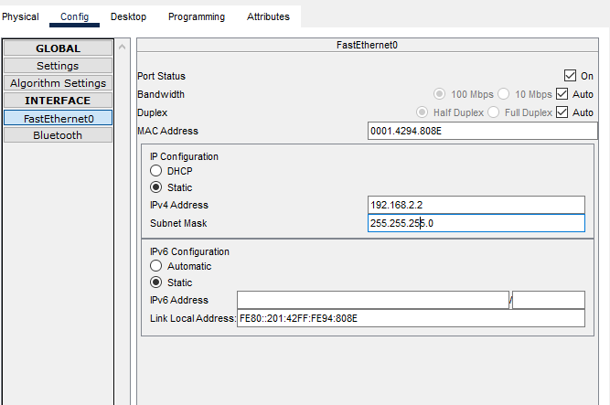
4. Repeat step-3 for 2nd Pc (IP-192.168.2.3 --- Subnet Mask -255.255.255.0)
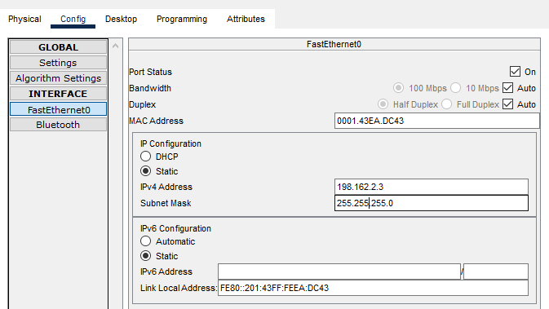
5. ping Pc1 to Pc2.
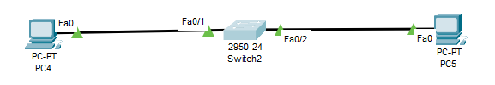
6. Send packet from Pc1 to Pc2 (Real time).
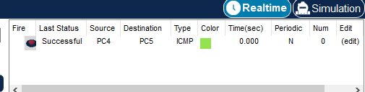
7. Send packet from Pc1 to Pc2 (Simulation).
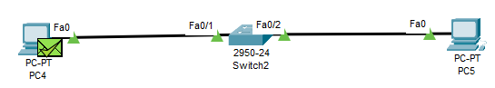

Lab Task 3
By using Drag and drop draw topology diagram as Shown below and attach screenshot of each step
1. Label each Laptop with unique ip address.
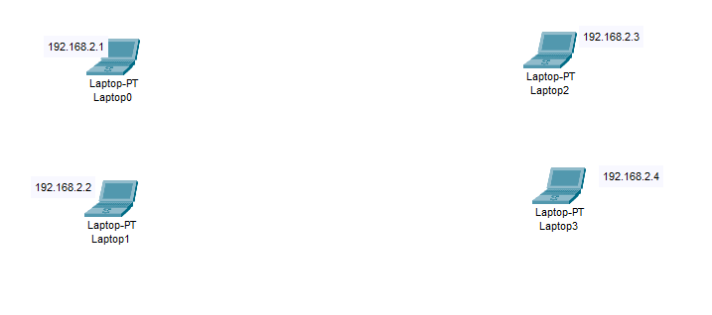
2. Highlight different sections
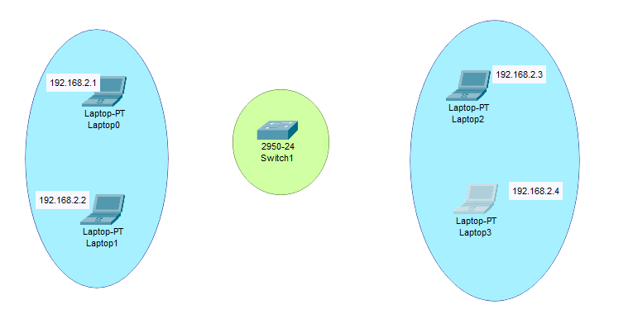
3. ping different Laptops.
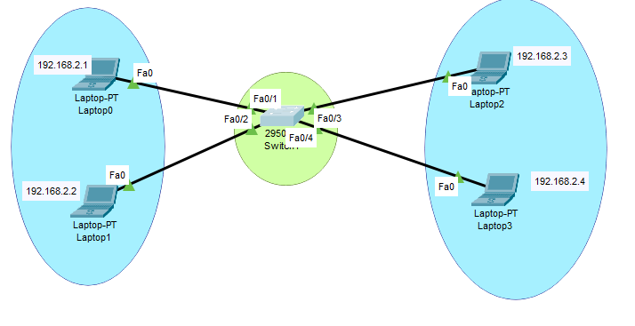
4. Send packet Laptop0 to Laptop3 (Real time).
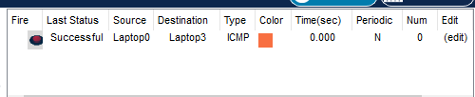
5. Send packet Laptop1 to Laptop2(Simulation).
